TERNA ENGINEERING COLLEGE
Department of Computer Engineering
NIRMAN LAB
Facilitating Theme-Based Experiential Learning for Real-World Engineering Solutions
Academic Year 2026 - 2027
A NIRMAN LAB PROJECT REPORT ON

TITLE: PM-JAY CLAIM GPS

Submitted in partial fulfilment of the term work requirement of Semester III
Bachelor of Engineering in Computer Engineering
Second Year of Engineering. Division: C
Submitted by

Name of student | Avdhut Parish Madhavi
Roll No. / PRN | TU3S2627005
Class, division and branch | COMP-SE-C-C2
Semester and academic year | 2026-27
Semester theme | “Arogya Pranali: Intelligent Health Systems for Bharat”
Project title | PM-JAY CLAIM GPS
Faculty mentor | Rohini Patil

Certificate
This is to certify that the project report entitled
TITLE: PM-JAY CLAIM GPS

is a bonafide work carried out by the following students of Semester III , Department of Computer Engineering, Terna Engineering College, under the Nirman Lab programme during the academic year
2026 – 2027, in partial fulfilment of the term work requirement.
Name of student | Roll No. / PRN
Avdhut Parish Madhavi | TU3S2627005
__________________________ __________________________ __________________________
Faculty Mentor | Head of Department | Principal/Director IQAC
Date: 22/10/2026 Place: Nerul

Approval Sheet
This project report entitled
is approved for the term work and oral examination of Semester ____ in the Nirman Lab
programme.
Internal Examiner: ___________________________________ Signature: ____________________
External Examiner: ___________________________________ Signature: ____________________
Date: ____________________ Place: ____________________

Declaration
I / We declare that this written submission represents my / our own ideas and work in my / our own words. Where others’ ideas, words, data, images, code or tools (including AI tools) have been included, they have been properly cited and acknowledged. Photographs and interviews were taken with the consent of the people involved. I / We understand that any violation of the above will be the cause for disciplinary action.
Name of student | Roll No. / PRN | Signature

Date: ____________________

Acknowledgement
I would like to express my sincere gratitude to my faculty mentor, subject faculty, and the Head of the Department for their valuable guidance, encouragement, and support throughout the development of my project, “PM-JAY Claim GPS.” Their suggestions and feedback helped me understand the problem more clearly and improve my proposed solution.
I am thankful to all the individuals who participated in my questionnaire and shared their opinions and experiences regarding the Pradhan Mantri Jan Arogya Yojana (PM-JAY). Their responses helped me understand the challenges people may face in learning about the scheme, understanding their eligibility, finding empanelled hospitals, and accessing relevant information.
I would also like to acknowledge the National Health Authority and NITI Aayog for the publicly available information and resources that helped me understand PM-JAY and the importance of healthcare accessibility, particularly in aspirational districts.
Finally, I am deeply grateful to my family for their constant encouragement, patience, and support throughout this project. Their motivation helped me remain focused and complete the work. This project has been a valuable learning experience, allowing me to explore how technology can make healthcare information more accessible and help people understand the next steps in seeking healthcare support.

Abstract
[150 to 200 words, one paragraph. Cover: the theme and SDG; the community problem and who is affected; what research showed; your final problem statement; the engineering knowledge applied; the solution and prototype; key validation results; the impact. Do not cite references in the abstract.]
The project PM-JAY Claim GPS is developed under the theme “Arogya Pranali: Intelligent Health Systems for Bharat” and aligns with Sustainable Development Goal 3 (Good Health and Well-being). It addresses difficulties faced by people in understanding the Pradhan Mantri Jan Arogya Yojana (PM-JAY), checking their eligibility, locating empanelled hospitals, and navigating healthcare support. A questionnaire involving 23 respondents revealed that 65% did not know their eligibility, 70% lacked awareness of the scheme’s benefits, and 74% expressed interest in applying. Based on these findings, the final problem statement is to simplify PM-JAY awareness and healthcare navigation for people facing information, language, and digital-access barriers. The proposed solution is a need-first digital platform that guides users from describing their healthcare needs to finding relevant hospital information, understanding document requirements, and accessing assistance. Engineering concepts in web development, database management, user-interface design, and information processing are applied in developing the website prototype. The questionnaire findings indicate a potential need for simplified guidance, while further usability testing and field validation are required. The project aims to improve awareness, simplify access to healthcare information, and support more inclusive, technology-enabled healthcare navigation in Bharat.
Keywords: PM-JAY, Arogya Pranali, Healthcare Accessibility, Intelligent Health Systems, Digital Healthcare

Nirman Architecture Canvas
1. Theme | 2. SDG Mapping | 3. Community Problem
Arogya Pranali: Intelligent Health Systems for Bharat | SDG 3: Good Health and Well-being. SDG 10: Reduced Inequalities. | People struggle to understand PM-JAY eligibility, find empanelled hospitals, and navigate healthcare benefits due to limited awareness, language barriers, and digital-access challenges.
4. Stakeholders | 5. Root Cause | 6. Subject Mapping
PM-JAY beneficiaries, patients, family members, ASHA workers, CSC operators, hospital help desks, and healthcare authorities. | Limited scheme awareness, unclear eligibility information, difficulty locating hospitals, complex procedures, and limited digital literacy. | Web Development, Database Management Systems, Software Engineering, UI/UX Design, and Information Processing.
7. Engineering Concepts Used | 8. Alternative Solutions | 9. Selected Solution
Responsive web design, database management, search and filtering, form validation, information retrieval, and multilingual interface design. | Awareness campaigns, printed guides, helpline support, community workshops, and a digital healthcare navigation platform. | PM-JAY Claim GPS: a need-first platform that guides users toward relevant hospital information, document guidance, and assistance.
10. Prototype | 11. Validation | 12. Impact
Interactive website prototype featuring healthcare need intake, hospital search, request tracking, multilingual support, and human assistance. | Questionnaire with 23 respondents. Findings: 65% were unaware of their eligibility, 70% lacked awareness of scheme benefits, and 74% wished to apply. Further usability testing is required. | Improved PM-JAY awareness, easier healthcare navigation, better access to relevant information, and reduced confusion about next steps.
13. Reflection | 14. Future Work | Project title/ team
The project highlighted the importance of accessible design, clear information, community feedback, and technology that addresses real healthcare-navigation problems. | Conduct field testing, improve regional-language support, integrate verified hospital data, strengthen offline functionality, and explore authorised PM-JAY service integrations. | PM-JAY Claim GPS — Individual Project by Avdhut Parish Madhavi, ID: TU3S2627005.
TABLE OF CONTENTS
 | Certificate | i
 | Approval Sheet | ii
 | Declaration | iii
 | Acknowledgement | iv
 | Abstract | v
 | Nirman Architecture Canvas | vi
Chapter 1: | Discover: Theme, Community and Problem Identification | 1
1.1 | Introduction and Semester Theme | 1
1.2 | SDG Mapping | 1
1.3 | Local Problem Identification | 1
1.4 | Community Observation | 1
1.5 | Learning Reflection (Discover) | 1
Chapter 2: | Research: Understanding Users and Existing Solutions | 2
2.1 | Research Methodology | 2
2.2 | Stakeholder Analysis | 2
2.3 | Survey and Interview Findings | 2
2.4 | Empathy Map and User Persona | 2
2.5 | Literature Review and Patent Search | 2
2.6 | Benchmarking | 2
2.7 | User Needs Document / Research Summary | 3
Chapter 3: | Define: Problem Statement and Root Cause Analysis | 3
3.1 | Problem Analysis (5 Whys) | 4
3.2 | Fishbone Diagram / Problem Tree | 4
3.3 | Engineering Constraints | 4
3.4 | Final Problem Statement | 4
3.5 | Objectives and Success Criteria | 4
Chapter 4: | Connect: Engineering Knowledge Applied | 4
4.1 | Subject Contribution Matrix | 5
4.2 | Concepts Applied: Worked Examples | 5
Chapter 5: | Ideation and Concept Selection | 5
5.1 | Techniques Used | 6
5.2 | Idea Bank (minimum 20 ideas) | 6
5.3 | Concept Sketches | 6
5.4 | Evaluation Matrix | 6
5.5 | Rejected Ideas and Reasons | 7

5.6 | Selected Concept and Justification | 7
Chapter 6: | Design | 8
6.1 | Design Overview | 8
6.2 | Design Iterations | 8
6.3 | Drawings and Models | 8
6.4 | Selection of Materials, Components and Tools | 8
6.5 | Bill of Materials and Cost | 8
Chapter 7: | Build: Prototype Development | 8
7.1 | Implementation Process | 10
7.2 | Prototype Photographs / Screenshots | 10
7.3 | Problems Faced and Solutions | 10
7.4 | Links to Code, CAD Files and Videos | 10
Chapter 8: | Validate: Testing and Results | 10
8.1 | Test Plan | 11
8.2 | User Testing and Feedback | 11
8.3 | Results and Performance | 11
8.4 | Failure Analysis | 11
8.5 | Improvements and Refinement | 11
Chapter 9: | Impact: SDG, Ethics, Safety and Cost | 11
9.1 | Beneficiaries | 13
9.2 | SDG Impact | 13
9.3 | Cost, Environmental and Social Impact | 13
9.4 | Ethics and Safety | 13
9.5 | Scalability and Sustainability | 13
Chapter 10: | Reflection, Conclusion and Future Work | 13
10.1 | Conclusion | 14
10.2 | Reflection | 14
10.3 | Limitations | 14
10.4 | Future Work | 14
 | References | 15
 | Appendices | 16

LIST OF FIGURES
Figure No. | Title of Figure | Page
Figure 1.1 | PM-JAY Claim GPS Project Workflow | ___
Figure 2.1 | Questionnaire Response: Age Distribution | ___
Figure 2.2 | Questionnaire Response: Hospitalisation History | ___
Figure 2.3 | Questionnaire Response: Existing Health Policy | ___
Figure 2.4 | Questionnaire Response: Awareness of PM-JAY | ___
Figure 2.5 | Questionnaire Response: Ayushman Card Ownership | ___
Figure 2.6 | Survey Analysis of PM-JAY Awareness and Eligibility | ___
Figure 3.1 | PM-JAY Claim GPS Website Homepage | ___
Figure 3.2 | Healthcare Need Intake Interface | ___
Figure 3.3 | Hospital Search Interface | ___
Figure 3.4 | Request Tracking and Human Assistance Interface | ___
Figure 4.1 | Primary Research: Field Survey Photograph | ___

ABBREVIATIONS AND SYMBOLS
Abbreviation / Symbol | Full form / Meaning
SDG | Sustainable Development Goal
PM-JAY | Pradhan Mantri Jan Arogya Yojana
NHA | National Health Authority
GPS | Global Positioning System (only if referring to location technology; otherwise, part of the project name)
UI | User Interface
UX | User Experience
DBMS | Database Management System
HTML | HyperText Markup Language
CSS | Cascading Style Sheets
API | Application Programming Interface
ASHA | Accredited Social Health Activist

Chapter 1: Discover: Theme, Community and Problem
Identification
Portfolio layer: Discover | Nirman Lab journey: Weeks 1 to 3
[Show that you observed before you solved. Explain what you saw, where, and why it matters. 3 to 4 pages.]
1.1 Introduction and Semester Theme
The semester theme, “Arogya Pranali: Intelligent Health Systems for Bharat,” focuses on using technology to improve healthcare accessibility, awareness, and service delivery in India. Healthcare schemes can provide valuable support, but people may face difficulties understanding their benefits, checking eligibility, finding suitable hospitals, and knowing the steps required to access assistance.
My project, PM-JAY Claim GPS, aims to address these challenges by providing a simple, need-first digital platform. Instead of requiring users to understand the entire PM-JAY scheme, the platform allows them to describe their healthcare needs and guides them towards relevant information, hospital discovery, document guidance, and human assistance.
The objective of this Nirman Lab project is to identify the difficulties people face while accessing PM-JAY information, understand the causes through primary research, and develop a practical website prototype that makes healthcare navigation easier. The project supports SDG 3: Good Health and Well-being by focusing on access to healthcare information and services.
1.2 SDG Mapping
SDG No. | Goal | Target | Relevance to My Problem
SDG 3 | Good Health and Well-being | 3.8: Achieve universal health coverage | Helps people understand healthcare support and navigate relevant services.
SDG 10 | Reduced Inequalities | 10.2: Promote inclusion for all | Aims to reduce information and digital-access barriers for people with limited digital literacy.
SDG 9 | Industry, Innovation and Infrastructure | 9.c: Increase access to information and communications technology | Uses a digital platform to make healthcare information easier to access.

1.3 Local Problem Identification
During the initial discovery stage, I focused on the difficulties people may experience when trying to understand and access the Pradhan Mantri Jan Arogya Yojana (PM-JAY). Potential problems included limited awareness of scheme benefits, uncertainty about eligibility, difficulty identifying empanelled hospitals, and confusion about the application or claim process.
To understand these issues better, I conducted a questionnaire involving 23 respondents. The findings showed that 65% did not know their PM-JAY eligibility, 70% lacked awareness of the scheme's benefits, and 74% expressed interest in applying for the scheme. These responses indicated a gap between people's interest in healthcare support and their understanding of how to access it.
Based on these findings, I selected PM-JAY awareness and healthcare navigation as the main problem to address. Other possible approaches, such as general awareness campaigns and printed information guides, could help, but a digital navigation platform could organise information and guide users through clear, sequential steps.
The final problem statement is:
“How might I help people understand PM-JAY benefits, navigate eligibility-related information, find relevant hospitals, and identify the next steps through a simple and accessible digital platform?”

1.4 Community Observation
My initial community research focused on understanding people's awareness of PM-JAY and the difficulties they might face when accessing healthcare support. I used a questionnaire to collect responses about scheme awareness, Ayushman Card ownership, eligibility understanding, existing health policies, previous hospitalisation, and willingness to apply.
The responses helped identify areas where clearer information and guidance may be useful. In particular, several respondents were uncertain about their eligibility and the benefits offered by the scheme. This suggested that making information easier to understand could be an important first step towards improving access.
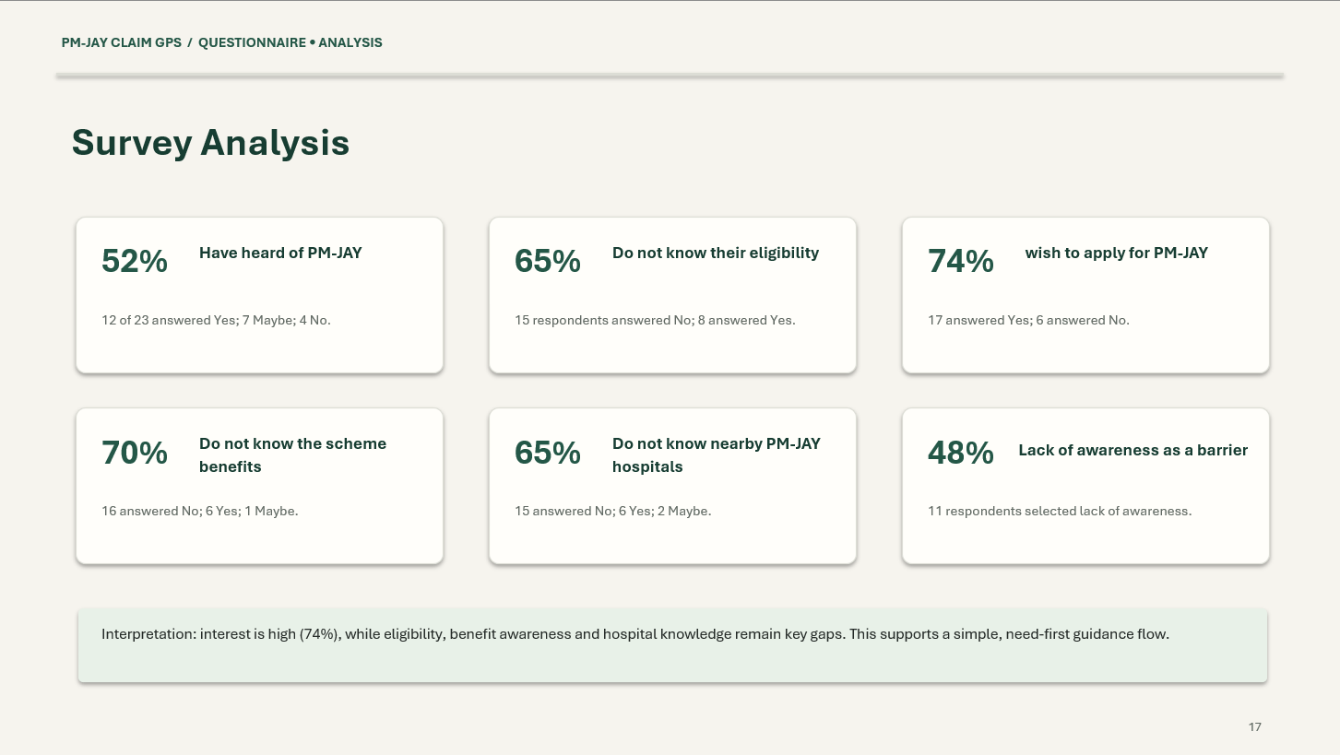
1.5 Learning Reflection (Discover)
During the discovery phase, I learned that awareness of a healthcare scheme does not necessarily mean that people understand its benefits or know how to access them. The questionnaire showed that although some respondents had heard of PM-JAY, many were still unsure about their eligibility or the benefits available.
Initially, I assumed that providing information about the scheme would be sufficient. However, the responses helped me recognise that people may also need practical guidance on where to go, what information to prepare, and what to do next. This changed my approach from creating a general awareness website to designing a need-first healthcare navigation platform.
The discovery process also highlighted the importance of simple language, accessible design, and human assistance. I learned that technology should not make the process more complicated for users; it should help them move forward with greater clarity and confidence.

Chapter 2: Research: Understanding Users and Existing
Solutions

2.1 Research Methodology
The research for PM-JAY Claim GPS was conducted to understand people's awareness of the Pradhan Mantri Jan Arogya Yojana (PM-JAY), their understanding of eligibility, and the difficulties they may face while accessing healthcare benefits. A questionnaire was prepared and distributed using Google Forms to collect responses from participants.
The questionnaire covered respondents' age, previous hospitalisation, existing health policies, awareness of PM-JAY, Ayushman Card ownership, understanding of eligibility, and willingness to apply for the scheme. A total of 23 responses were analysed to identify common patterns and potential gaps in awareness.
The collected responses were examined using charts and percentage calculations. The findings helped identify the main problem areas and informed the proposed features of the website, including simple healthcare guidance, hospital information, document guidance, and human assistance.
Research tools: Google Forms, questionnaire responses, charts, and percentage analysis.
Limitations: The sample consisted of 23 respondents and may not represent the wider population. The findings reflect the responses collected and do not establish the actual eligibility of participants for PM-JAY.

2.2 Stakeholder Analysis
Stakeholder group | Who exactly | Need / concern | Method used
Primary users | People seeking information about PM-JAY and healthcare benefits | Understand eligibility, benefits, and the next steps | Questionnaire
Secondary users | Family members, ASHA workers, CSC operators, and hospital help-desk staff | Help people access accurate information and navigate the process | Stakeholder identification and problem analysis
Influencers | National Health Authority, healthcare authorities, and relevant government organisations | Provide accurate scheme information and support reliable service navigation | Review of publicly available information

2.3 Survey and Interview Findings
The questionnaire results revealed several important findings about PM-JAY awareness and accessibility among the 23 respondents.
Survey finding | Result | Interpretation
Respondents who did not know their PM-JAY eligibility | 65% | Eligibility guidance may need to be clearer.
Respondents unaware of the scheme's benefits | 70% | Better explanation of scheme benefits may be useful.
Respondents interested in applying for PM-JAY | 74% | Many respondents expressed interest in applying.
Respondents who had heard of PM-JAY | 52% | Awareness was not universal in this sample.
Respondents who did not know nearby PM-JAY hospitals | 65% | Hospital discovery is a relevant feature to investigate.
Respondents who cited lack of awareness as a barrier | 48% | Awareness is one of the reported challenges.
Key observations
The survey showed that interest in applying for PM-JAY was relatively high, while awareness of eligibility and scheme benefits remained limited among respondents. This suggests that simply publicising the scheme may not be enough; people may also need practical guidance on how to proceed.
One important observation was the gap between interest in applying and understanding eligibility. This supports the need for a platform that begins with the user's healthcare requirement and provides understandable next steps.

2.4 Empathy Map and User Persona
Empathy map
The following is a hypothetical persona based on the types of barriers explored in the project. It is not a direct quotation from an individual respondent.
Says | Thinks
“How can I find out whether I can benefit from this scheme?” | “I am not sure where to begin or which information is correct.”
“Which hospital should I visit?” | “I do not want to waste time visiting the wrong place.”

Does | Feels
Searches online, asks family members, or seeks help from local health workers | Confused by complicated information
Tries to find hospitals and understand the required documents | Uncertain about the next steps
User persona
A typical PM-JAY information seeker
Illustrative persona: Sunita
Age: 40–55 · Location: Rural or semi-urban India · Occupation: To be adapted to actual user research
Sunita wants to understand whether PM-JAY can help her family access hospital treatment but is unsure how to check eligibility or identify a suitable hospital.
Goals
- Understand the scheme in simple language.
- Find relevant hospital information.
- Know which documents may be needed.
Frustrations
- Unclear eligibility information.
- Difficulty finding reliable hospital details.
- Uncertainty about whom to contact for assistance.

2.5 Literature Review and Patent Search
# | Source and type | What it does | Gap / limitation
1 | National Health Authority (NHA) – Official PM-JAY portal | Provides information about PM-JAY, scheme benefits, and related services. | Users may still need help understanding the information and identifying the next steps.
2 | PM-JAY hospital search and beneficiary services – Government service | Helps users access relevant scheme and hospital information through official channels. | Users unfamiliar with the process may find it difficult to navigate the available services.
3 | NITI Aayog – Aspirational Districts Programme | Focuses on improving development outcomes, including health, in aspirational districts. | Does not itself provide the specific need-first navigation workflow proposed by this project.
4 | ASHA workers and Common Service Centres (CSCs) – Community support channels | Help people access health-related information and digital public services. | Access to assistance can depend on local availability and users knowing where to seek help.
5 | Digital healthcare portals and mobile applications – Existing technology solutions | Provide online access to healthcare information, services, and hospital-related resources. | Some digital services may require internet access, digital literacy, or familiarity with healthcare terminology.

2.6 Benchmarking
This section compares existing approaches with the proposed PM-JAY Claim GPS solution.
Feature | Official PM-JAY information services | Community assistance | PM-JAY Claim GPS (proposed)
Access to scheme information | Available through official channels | Explained through personal assistance | Provides a simplified information interface
Starting point | Scheme information or a specific service | User explains their concern | User starts by describing their healthcare need
Hospital discovery | Through available official services | Guidance from a support person | Searchable hospital directory using verified data
Document guidance | Depends on the service and process | Explained by the support person | Organised checklist and next-step guidance
Language accessibility | Depends on the particular service | Can provide local-language assistance | Designed for English, Hindi, and Marathi
Human support | Available through designated channels | Direct interaction | Provides routes to appropriate support channels
Low-connectivity support | Depends on the service | May work without internet | Planned offline drafts and low-bandwidth features
Claim verification | Through authorised official systems | Guidance to official channels | Does not replace official verification

Benchmarking conclusion: PM-JAY Claim GPS is intended to complement existing government and community services rather than replace them. Its main difference is the need-first approach, which aims to help users move from describing a healthcare requirement to understanding the next practical step.

2.7 User Needs Document / Research Summary
Based on the questionnaire results and the problem analysis, the following user needs were identified:
- Simple information: Users need PM-JAY information explained in clear, understandable language.
- Eligibility guidance: Users need to understand how to check their eligibility through appropriate official channels.
- Benefit awareness: Users need clear explanations of the scheme's benefits and limitations.
- Hospital discovery: Users need help finding relevant PM-JAY empanelled hospitals using reliable information.
- Document guidance: Users need to understand which documents may be required for their particular situation.
- Step-by-step navigation: Users need a clear sequence of actions rather than having to navigate multiple sources independently.
- Regional-language support: Users should be able to access important instructions in familiar languages.
- Human assistance: Users need an alternative when they cannot understand the information or complete a digital process.
- Low-connectivity access: Users need essential guidance and safe draft-saving options when internet connectivity is unreliable.
- Reliable information: Users need information with identifiable sources and appropriate verification, without misleading promises about eligibility or claim approval.
Research summary: The questionnaire involving 23 respondents found that 65% did not know their eligibility, 70% lacked awareness of scheme benefits, and 74% expressed interest in applying. These preliminary findings support further development and testing of a simplified healthcare navigation platform. The proposed solution should be validated with additional users before drawing conclusions about its effectiveness.

Chapter 3: Define: Problem Statement and Root Cause
Analysis
3.1 Problem Analysis (5 Whys)
Observed problem: People may be interested in PM-JAY but lack clarity about eligibility, scheme benefits, and how to access relevant healthcare support.
Why | Question | Answer
1 | Why do people struggle to access PM-JAY benefits? | They may not know whether they are eligible or what steps to follow.
2 | Why are they unsure about the process? | Information about benefits, eligibility, hospitals, and documents may be difficult to understand or navigate.
3 | Why is navigating this information difficult? | Users may need to consult different sources or understand unfamiliar terminology.
4 | Why can this create barriers? | People with limited digital literacy, language barriers, or unreliable internet may find independent navigation challenging.
5 | Why does this problem persist? | There is a need for clearer, user-centred guidance that connects a person's healthcare need with reliable information and practical next steps.
Root cause identified: Difficulty accessing, understanding, and navigating PM-JAY information in a simple, connected, and user-friendly manner.
3.2 Fishbone Diagram / Problem Tree
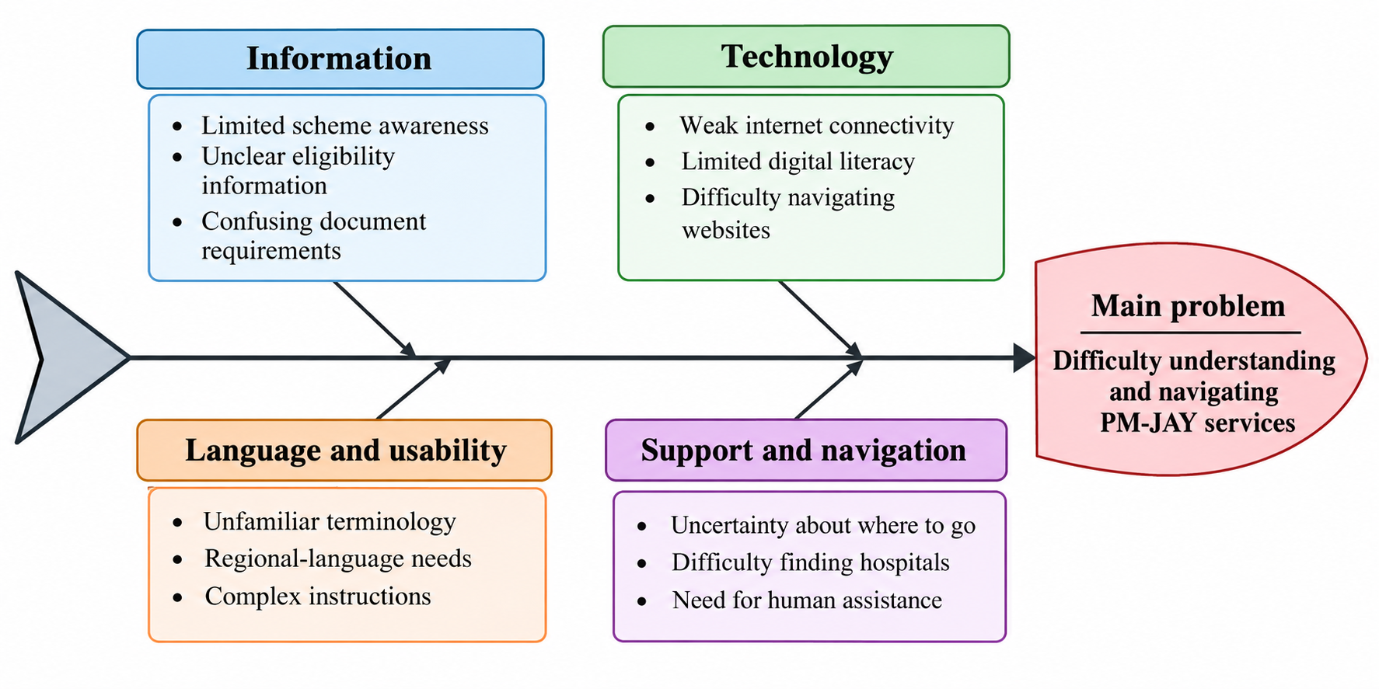

3.3 Engineering Constraints
Constraint | Description | How it will be addressed
Cost | The project must be affordable to develop and maintain. | Use open-source technologies and suitable free-tier services.
Time | Development and testing must fit within the academic project schedule. | Prioritise core features before optional integrations.
Connectivity | Some users may have weak or intermittent internet. | Provide lightweight pages and safe local draft saving.
Language | Users may prefer different regional languages. | Provide English, Hindi, and Marathi interface options.
Data accuracy | Hospital details and scheme information may change. | Use reliable sources and display verification dates where available.
Privacy and security | Healthcare-related requests may contain sensitive information. | Minimise collected data and apply appropriate security controls.
Technical skills | The application must be manageable within the available development resources. | Use established web technologies and modular architecture.
Official access | Actual eligibility and claim information may require authorised government integrations. | Direct users to official channels and avoid unsupported claims.

3.4 Final Problem Statement
People seeking PM-JAY healthcare support need a simple and accessible way to understand scheme information, find relevant hospitals, and identify the next steps because limited awareness, unclear eligibility information, language barriers, and digital-access challenges can make the process difficult to navigate.
3.5 Objectives and Success Criteria
Objective | Success criterion
1. Improve access to scheme guidance | Users can locate relevant guidance through a clear, need-first workflow.
2. Simplify healthcare navigation | Users can complete the core journey from describing a need to viewing next-step guidance.
3. Support hospital discovery | Users can search and filter available hospital records and view their sources where provided.
4. Improve accessibility | Core workflows support mobile screens, readable text, keyboard access, and language selection.
5. Validate usability | Conduct user testing, record task completion and difficulties, and use feedback to improve the prototype.

Chapter 4: Connect: Engineering Knowledge Applied
Portfolio layer: Connect | Nirman Lab journey: Week 7
[This is the link to your Nirman Lab. Show how each semester subject contributes to your solution. 2 to 3 pages.]
4.1 Subject Contribution Matrix
Semester subject | Concept / topic applied | How it helped my solution | Where used (section)
AIPS (Algorithms and Intelligent Problem Solving) | Algorithms, searching, sorting, problem-solving techniques | Helps design logical steps for searching hospitals, filtering results, and guiding users through the healthcare navigation process. | Hospital Finder and Navigation
ASPD (Applied Statistics and Probability for Data Science) | Data collection, percentages, statistical analysis, data interpretation | Helps analyse questionnaire responses and identify gaps in PM-JAY awareness and eligibility understanding. | Survey Analysis and Research
DBMS (Database Management Systems) | Database design, CRUD operations, queries, data validation | Supports storing and retrieving hospital information, guidance content, and assistance requests. | Backend and MongoDB Atlas
LR (Logical Reasoning) | Logical analysis, assumptions, cause-and-effect reasoning | Helps identify root causes, analyse the five whys, and organise the sequence of questions and guidance presented to users. | Problem Analysis and User Workflow
JAVA | Object-oriented programming, classes, objects, methods, conditional statements | Provides knowledge of modular programming and structured logic that can be applied when designing application components and processing user requests. | Application Logic and Software Design

4.2 Concepts Applied: Worked Examples
Concept / method | Worked example or calculation | How it applies to the solution
ASPD: Percentage calculation | (15/23 x 100 =65.22%) of respondents did not know their PM-JAY eligibility. | Quantifies the eligibility-awareness gap and supports the need for clear guidance.
AIPS: Searching algorithm | Search a hospital list by comparing the user's selected district with each hospital's district, then return matching records. | Helps users find relevant hospitals efficiently.
DBMS: CRUD operations | Create an assistance request, read its status, update an authorised status, and retrieve relevant hospital information. | Enables persistent storage and retrieval through MongoDB Atlas and the backend.
LR: Five Whys analysis | Difficulty accessing PM-JAY information → unclear eligibility → confusing information → navigation barriers → need for simpler guidance. | Identifies the underlying problem that the website is designed to address.
JAVA: Conditional statements | if (requestCategory.equals("Hospital Navigation")) { ... } | Demonstrates how application logic can direct a user to the appropriate workflow.
Worked example 1: ASPD survey analysis
Given:
- Total respondents = 23
- Respondents who did not know their eligibility = 15
\[ \text{Percentage}=\frac{15}{23}\times100=65.22\% \]
Therefore, approximately 65.2% of respondents were unaware of their PM-JAY eligibility. This finding supports prioritising eligibility guidance in the proposed platform.
Worked example 2: AIPS hospital search
Suppose the database contains hospitals in three districts. A user selects a district, and the search algorithm compares that selection with the district field of each hospital record. Matching records are returned for display.
This demonstrates how algorithms can help users narrow down hospital results. Actual hospital details and PM-JAY empanelment status must come from reliable data sources.

Chapter 5: Ideation and Concept Selection
5.1 Techniques Used
The following techniques were used to explore possible solutions:
- Brainstorming: Generated different ideas to improve PM-JAY awareness and healthcare navigation.
- Design Thinking: Focused on understanding user difficulties before selecting a solution.
- SCAMPER: Explored ways to simplify existing healthcare information and support processes.
- Mind Mapping: Connected the main problem with its causes, stakeholders, and potential solutions.
- Concept Evaluation: Compared shortlisted ideas using feasibility, impact, cost, innovation, and sustainability.

5.2 Idea Bank (minimum 20 ideas)
No. | Idea | No. | Idea
1 | PM-JAY information website | 11 | Healthcare FAQ chatbot
2 | PM-JAY Claim GPS navigation platform | 12 | Hospital search and filter system
3 | SMS-based scheme information service | 13 | Document checklist generator
4 | Voice-based healthcare guidance | 14 | Eligibility information guide
5 | Regional-language awareness app | 15 | Claim GPS request-tracking system
6 | Interactive PM-JAY FAQ portal | 16 | ASHA worker assistance directory
7 | Hospital location directory | 17 | Step-by-step application guide
8 | Community awareness campaign | 18 | Low-internet healthcare information portal
9 | Printed PM-JAY information booklet | 19 | Audio-based scheme instructions
10 | Video tutorials explaining PM-JAY | 20 | Integrated healthcare navigation and assistance platform

5.3 Concept Sketches
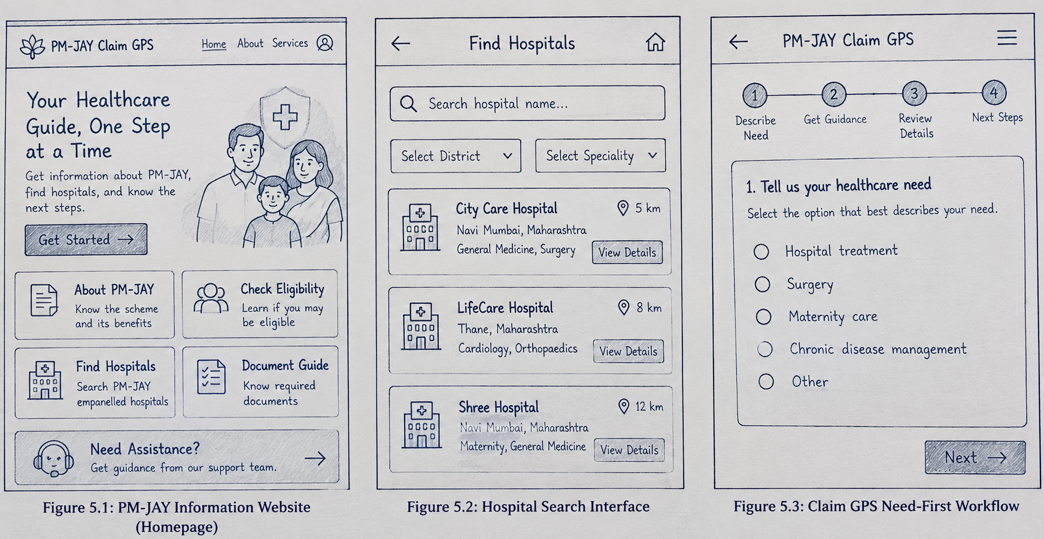
5.4 Evaluation Matrix

Score each concept from 1 to 5, where 5 is the most favourable score. For cost, a higher score means lower implementation cost.
- Concept A: General PM-JAY information website
- Concept B: SMS and voice-based information service
- Concept C: PM-JAY Claim GPS navigation platform
Criteria | Concept A | Concept B | Concept C
Feasibility | 5 | 3 | 4
Impact on users | 3 | 4 | 5
Cost | 5 | 3 | 4
Innovation | 2 | 4 | 5
Sustainability | 4 | 3 | 4
Total / 25 | 19 | 17 | 22
These are preliminary design judgements, not measured evaluation results. The scoring should be reviewed against your actual development constraints.
5.5 Rejected Ideas and Reasons
Idea | Reason for not selecting it as the main solution
General information website | Provides information but may not guide users through their specific healthcare needs.
SMS-only service | Useful for basic phones but limited for detailed hospital information and interactive navigation.
Voice-only service | Improves accessibility but may be difficult to implement comprehensively within the project timeline.
Printed information booklet | Low cost and accessible offline, but information can become outdated and is not interactive.
Standalone FAQ chatbot | Answers common questions but may not provide an integrated journey covering hospitals, documents, and assistance.

5.6 Selected Concept and Justification
The selected concept is PM-JAY Claim GPS, a need-first healthcare navigation platform designed to simplify access to information about the Pradhan Mantri Jan Arogya Yojana.
The concept was selected because it addresses multiple difficulties identified during the research phase, including limited awareness of scheme benefits, uncertainty about eligibility, and difficulty identifying relevant hospitals. Instead of requiring users to understand the entire scheme before getting started, the platform allows them to describe their healthcare need and follow a sequence of understandable steps.
The proposed website includes healthcare need intake, hospital search, document guidance, request tracking, multilingual interface options, and routes to human assistance. Its design emphasises simple language, mobile responsiveness, and accessible navigation.
Compared with a general information website or a single-channel SMS service, Claim GPS aims to connect several navigation tasks within one interface. It is intended to complement official PM-JAY services rather than replace them. Official eligibility checks, hospital empanelment, and claim decisions must remain subject to confirmation through authorised sources.

Chapter 6: Design
6.1 Design Overview
PM-JAY Claim GPS is designed as a need-first healthcare navigation website. It helps users move from describing their healthcare needs to finding relevant information and understanding the next steps.
The system follows a client-server architecture. The frontend provides the user interface, the backend processes requests, and MongoDB Atlas stores application data such as assistance requests, hospital records, and guidance content.
The primary workflow is:
- The user describes their healthcare need.
- The system presents relevant guidance.
- The user searches for hospital information or document requirements.
- The user can access assistance or submit a Claim GPS request.
- The application provides a reference number for an appropriately implemented request-tracking workflow.
Official PM-JAY eligibility and claim decisions remain with authorised channels.

6.2 Design Iterations
Iteration | Design / drawing reference | What changed and why | Result
Iteration 1 | Initial PM-JAY information website sketch | Started with a general information-focused layout. | Basic scheme information and navigation were identified.
Iteration 2 | Hospital search and need-first workflow sketches | Added hospital discovery and a step-by-step journey because users may need practical guidance, not only scheme information. | The design became more task-oriented.
Iteration 3 | Responsive PM-JAY Claim GPS website design | Organised key actions such as describing a need, finding hospitals, checking a request, and seeking assistance. | A clearer, more accessible design direction was established.

6.3 Drawings and Models
The main design models for this project are:
- System architecture diagram: Shows communication between the frontend, backend API, and database.
- User workflow diagram: Shows how users describe their healthcare needs and reach the next step.
- UI wireframes: Illustrate the homepage, hospital search interface, and need-first workflow.
- Database model: Defines the relationships and fields for hospital information, guidance content, and assistance requests.
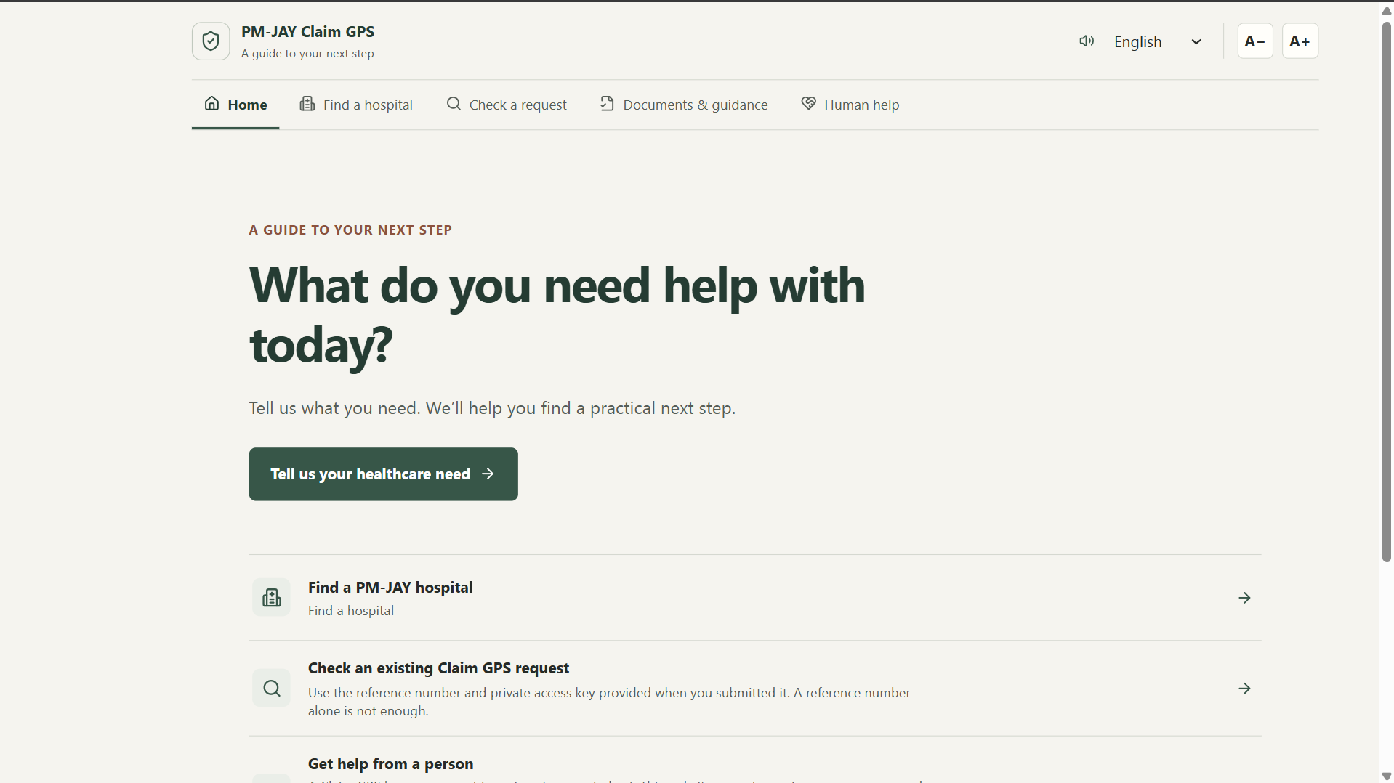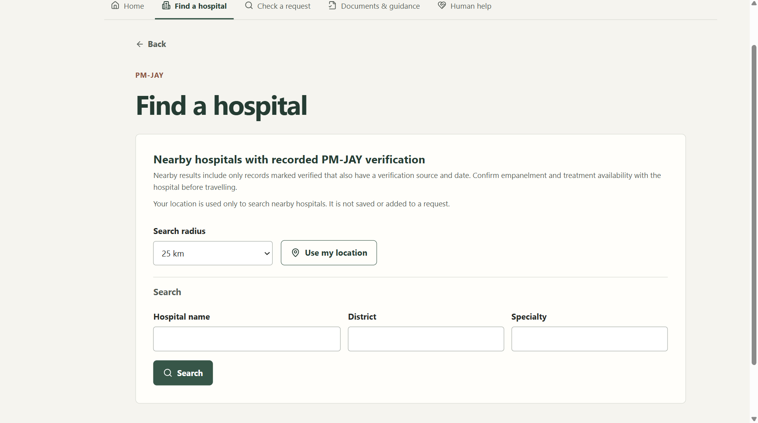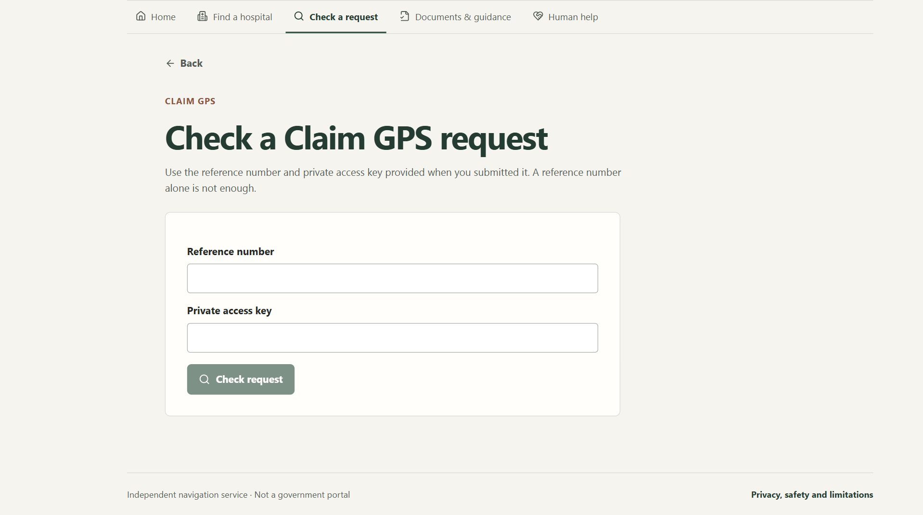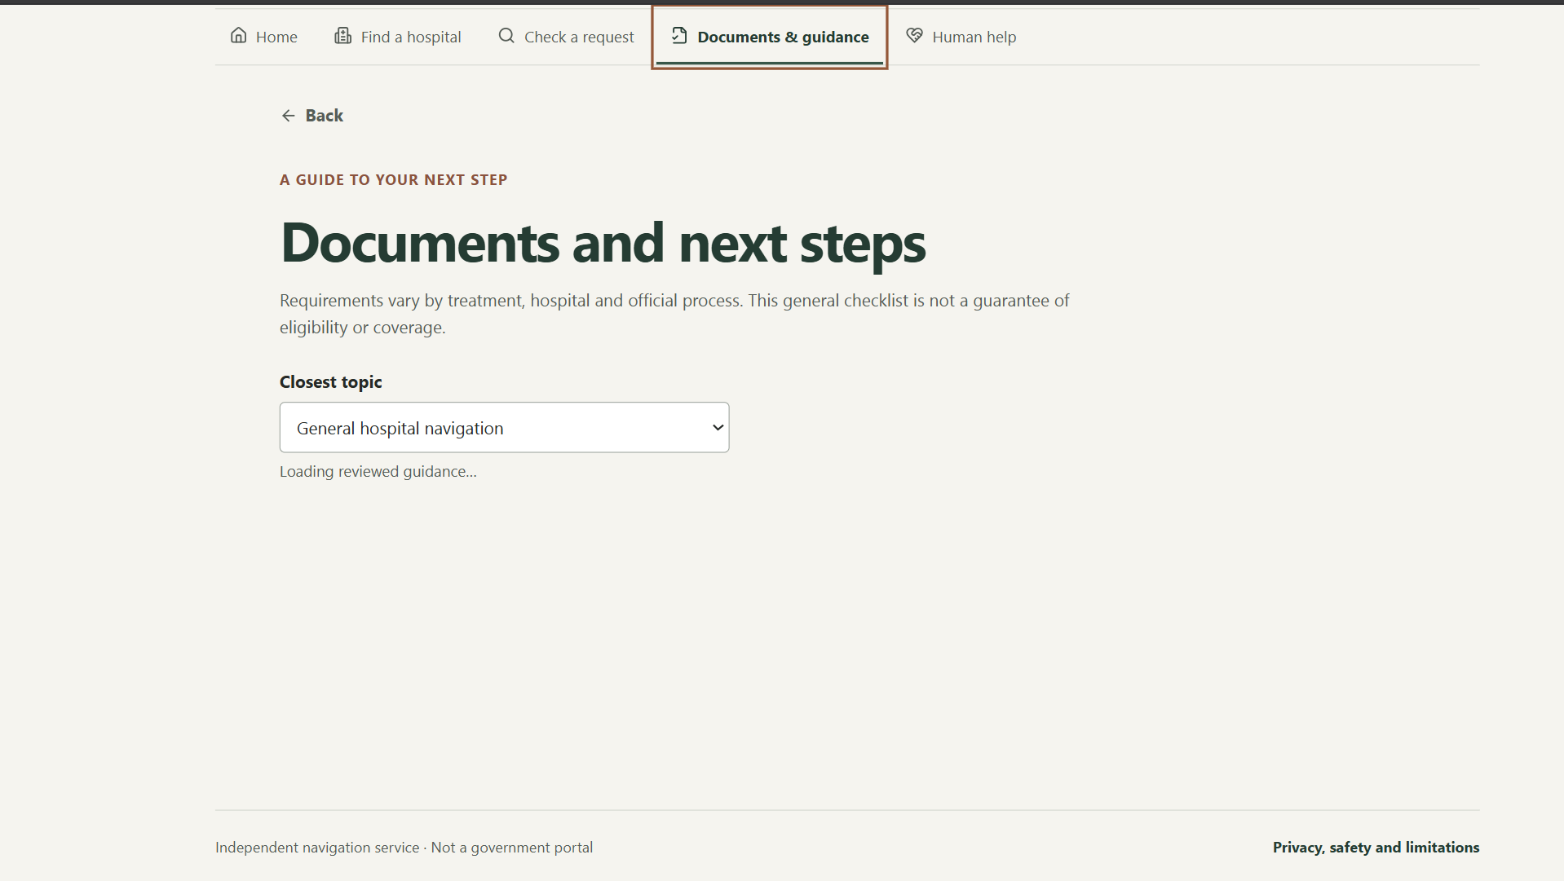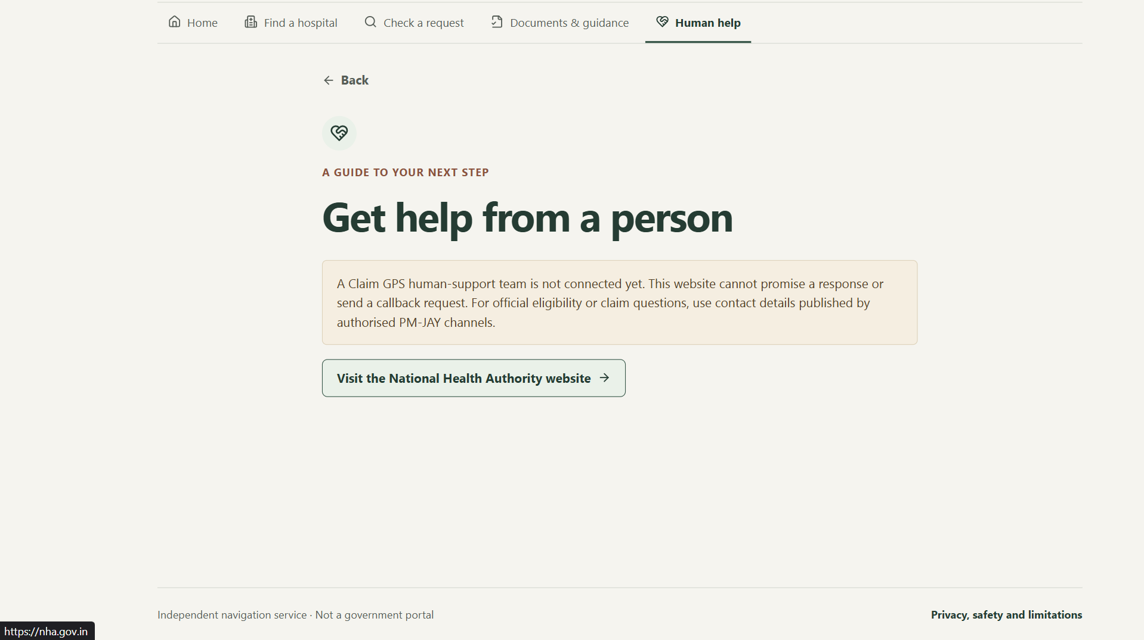
6.4 Selection of Materials, Components and Tools
Component / tool | Reason for selection
React | Supports reusable interface components and interactive workflows.
Tailwind CSS | Enables consistent styling and responsive layouts.
Node.js and Express | Provide backend APIs for processing requests and retrieving data.
MongoDB Atlas | Provides cloud-based persistent storage for application records.
Git and GitHub | Support version control and tracking changes during development.
Browser developer tools | Help test responsive layouts, identify errors, and debug the application.
Lucide icons | Provide consistent, readable interface icons.

6.5 Bill of Materials and Cost
Item | Qty | Unit cost | Total
React, Node.js, Express and Tailwind CSS | 1 set | ₹0 | ₹0
MongoDB Atlas and hosting services | 1 setup | ₹0* | ₹0*

Chapter 7: Build: Prototype Development

7.1 Implementation Process
The PM-JAY Claim GPS website was planned as a need-first healthcare navigation platform to simplify access to information about the Pradhan Mantri Jan Arogya Yojana (PM-JAY). The development process involved the following steps:
1. Requirement identification: I identified the key user needs from the questionnaire findings, including awareness of scheme benefits, eligibility information, hospital discovery, and guidance on the next steps.
2. Interface design: I planned the website layout to keep the navigation simple and make the main actions easy to find. The design focuses on readability, accessibility, and responsive layouts for mobile and desktop devices.
3. Frontend development: I used web development technologies to structure the pages, style the interface, and implement interactive elements such as forms, buttons, search fields, and navigation.
4. Backend development: I planned the server-side logic to process user requests, validate submitted information, and provide relevant guidance through application programming interfaces.
5. Database integration: MongoDB Atlas was selected for storing application data, such as assistance requests and hospital records, subject to the implemented data model and available verified information.
6. Testing and refinement: The website workflows were reviewed for navigation, form validation, responsiveness, and usability. Further testing is required to validate the experience with actual users.

7.2 Prototype Photographs / Screenshots
Figure 7.1: PM-JAY Claim GPS Homepage
The homepage introduces the platform and provides access to the main healthcare navigation features.
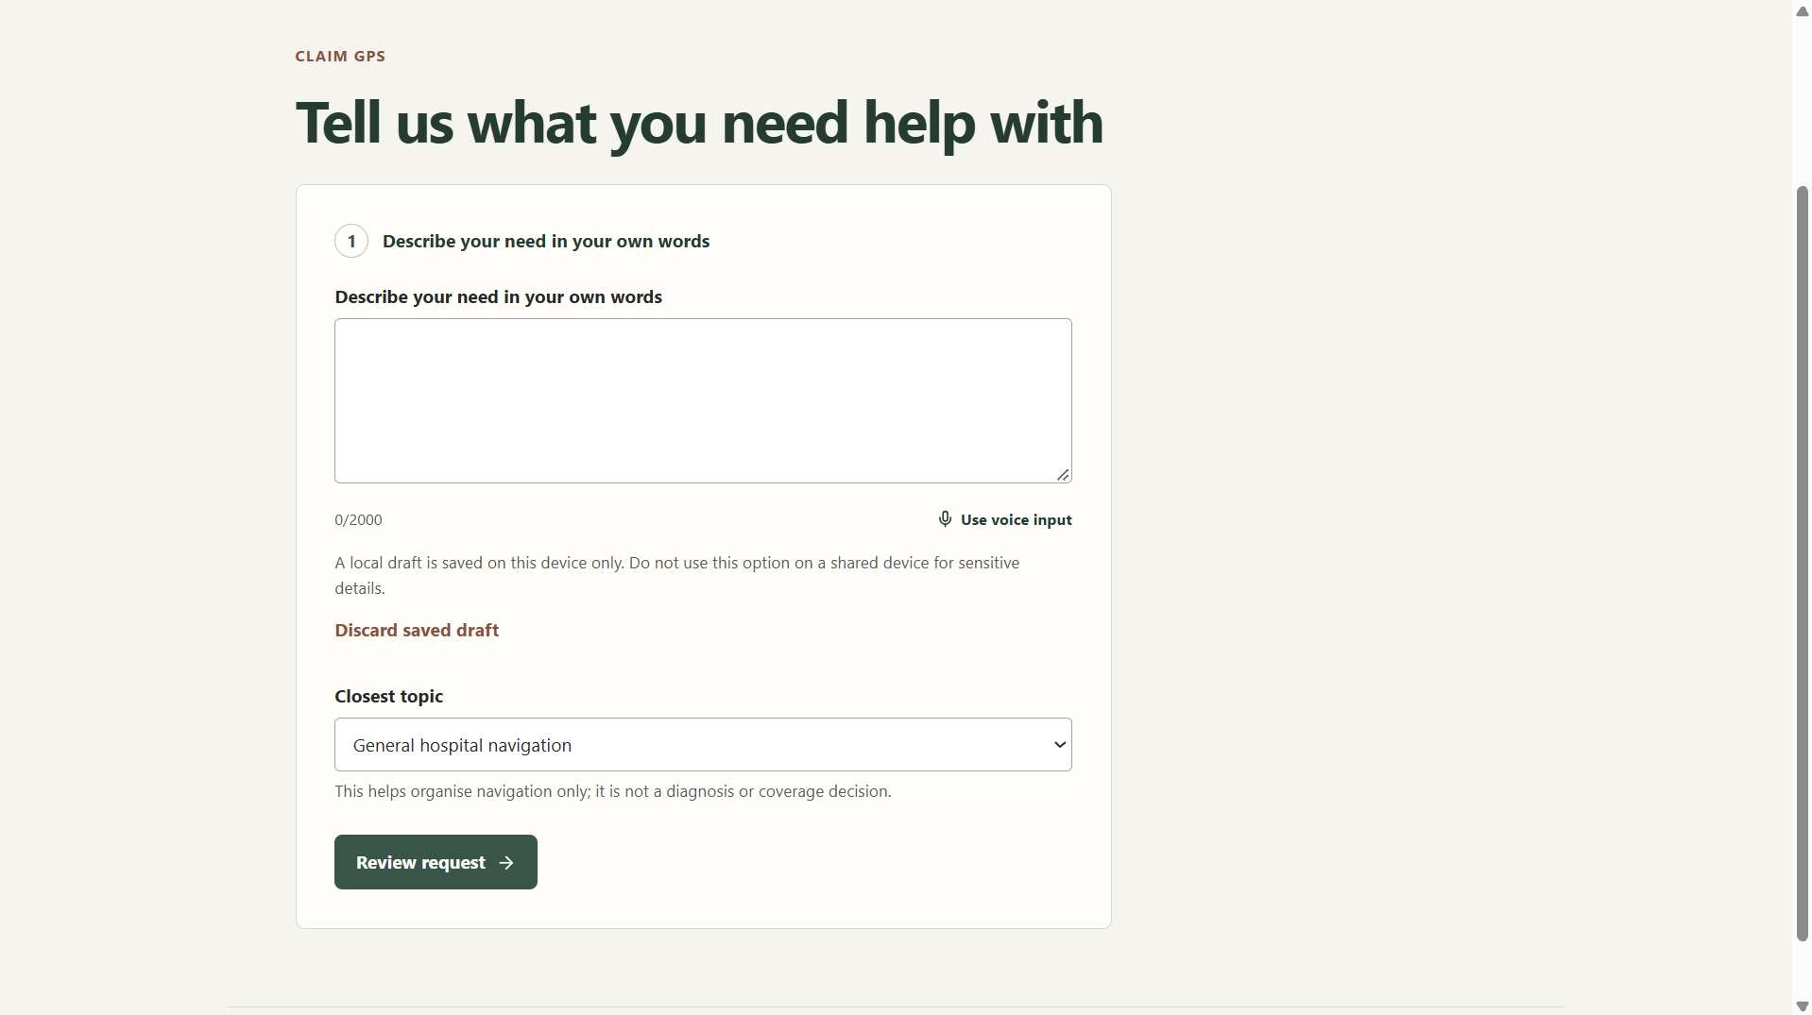
Figure 7.2: Healthcare Need Intake Interface
The interface allows users to describe their healthcare information needs and proceed to relevant guidance.

Figure 7.3: Hospital Search Interface
The hospital finder is intended to help users search available hospital records and view relevant details.

Figure 7.4: Request Tracking and Assistance Interface
This screen demonstrates the intended process for viewing an assistance request or finding further support.

7.3 Problems Faced and Solutions
Problem faced | Solution / approach
Making healthcare information easy to understand | Organised the interface around clear actions and simple instructions.
Designing a layout for different screen sizes | Used responsive layout principles and planned mobile-friendly controls.
Connecting the frontend to the database | Selected a backend API layer to validate requests and communicate with MongoDB Atlas.
Maintaining accurate hospital information | Identified the need to use verified data sources and avoid presenting unverified records as official.
Protecting user information | Planned data minimisation, server-side validation, and secure handling of database credentials.
Distinguishing assistance tracking from official claim status | Designed the project as a navigation assistant rather than an authority for official eligibility or claim decisions.

7.4 Links to Code, CAD Files and Videos

Resource | Link
Source code repository | https://github.com/avdhutmadhavi/PMJAYCLAIM.git
Live website | https://pmjay-claim-gps.onrender.com/

Chapter 8: Validate: Testing and Results
8.1 Test Plan
The purpose of testing is to evaluate whether PM-JAY Claim GPS helps users navigate healthcare information clearly and complete the main website workflows. Testing should focus on usability, functionality, accessibility, and data reliability.
Test area | What will be tested | Method | Success criteria
Navigation | Accessing the main website sections | Task-based testing | Users can find the required section.
Healthcare need form | Entering and submitting a request | Functional testing | Valid inputs are accepted and invalid inputs show clear errors.
Hospital search | Searching and filtering hospital records | Functional testing | Relevant matching records are displayed.
Request tracking | Retrieving an assistance request | Integration testing | A valid reference retrieves the corresponding request, subject to access controls.
Responsive design | Mobile and desktop layouts | Device/browser testing | Content remains readable and controls are usable without horizontal scrolling.
Accessibility | Text readability, keyboard navigation, and contrast | Accessibility review | Core tasks can be completed using accessible controls.

8.2 User Testing and Feedback

# | Tester (role / age) | Feedback / observation | Action taken
1 | Aarayan | Homepage should make the main actions easier to find. | Made the primary actions more prominent.
2 | Afia Khan | Healthcare need form should use simple language. | Simplified the instructions and field labels.
3 | Mayuresh Shelke | Hospital search should make results easier to understand. | Improved the search filters and results layout.
4 | Shrawani Kasar | Text and language options should be easier to read and find. | Improved readability and language selector visibility.
5 | Pradnesh Ashok Jadhav | Request tracking should explain the displayed status clearly. | Added clearer status descriptions and a note distinguishing assistance requests from official PM-JAY claims.

8.3 Results and Performance
The questionnaire results from 23 respondents revealed the following findings about PM-JAY awareness and accessibility.
Parameter | Result | Interpretation
Awareness of PM-JAY | 52% (12 of 23) answered Yes | Awareness of the scheme is limited among some respondents.
Knowledge of eligibility | 65% (15 of 23) did not know their eligibility | Clear eligibility guidance is needed.
Interest in applying | 74% (17 of 23) answered Yes | Most respondents expressed interest in applying for the scheme.
Awareness of scheme benefits | 70% (16 of 23) did not know the benefits | Information about scheme benefits needs to be easier to understand.
Knowledge of nearby PM-JAY hospitals | 65% (15 of 23) did not know nearby hospitals | Hospital-finding guidance could help address this gap.
Lack of awareness as a barrier | 48% (11 of 23) selected lack of awareness | Awareness is an important barrier identified by respondents.

8.4 Failure Analysis
During testing, potential failure points to investigate include:
Potential failure | Possible cause | Lesson / corrective approach
Users cannot find eligibility guidance | Unclear navigation or unfamiliar wording | Make the guidance entry point more visible.
Hospital search returns no results | Incorrect filters or incomplete data | Improve empty-state messages and data validation.
Request tracking fails | Invalid reference or backend/database error | Validate inputs and show clear error messages.
Website is difficult to use on mobile | Layout or touch-target issues | Test on different screen sizes and refine responsive styling.
Users mistake assistance status for official claim status | Unclear wording | Explicitly distinguish Claim GPS assistance requests from official PM-JAY claims.

8.5 Improvements and Refinement
Feedback | Change Made | Improvement Observed
The homepage navigation needed to be clearer. | Organised the main actions into easily identifiable sections. | Users can identify the main features more easily.
Healthcare guidance needed simpler language. | Simplified instructions and improved field labels. | The workflow becomes easier to understand.
Hospital search needed better organisation. | Improved search filters and hospital result presentation. | Users can locate relevant hospital information more easily.
Request tracking needed clearer explanations. | Added status descriptions and clarified that tracking refers to Claim GPS assistance requests, not official PM-JAY claims. | Reduces confusion about request status.

Chapter 9: Impact: SDG, Ethics, Safety and Cost

9.1 Beneficiaries
The primary beneficiaries of PM-JAY Claim GPS are people who need help understanding PM-JAY, checking eligibility, finding empanelled hospitals, and identifying the steps required to access healthcare benefits. Secondary beneficiaries include family members, ASHA workers, CSC operators, and hospital help-desk staff who assist people in navigating healthcare services.
The initial questionnaire involved 23 respondents and identified gaps in scheme awareness and eligibility understanding. The platform could benefit a wider population if implemented and validated successfully, particularly people with limited digital literacy, language barriers, or unreliable internet access.

9.2 SDG Impact
SDG | Target | Contribution
SDG 3: Good Health and Well-being | Target 3.8: Universal health coverage | Helps users navigate healthcare information and understand available support.
SDG 10: Reduced Inequalities | Target 10.2: Promote inclusion for all | Aims to reduce information and digital-access barriers.
SDG 9: Industry, Innovation and Infrastructure | Target 9.c: Access to information and communications technology | Uses digital technology to improve access to healthcare information.
Impact indicators: Number of users accessing guidance, hospital searches completed, assistance requests submitted, task completion rate, and user satisfaction.

9.3 Cost, Environmental and Social Impact
PM-JAY Claim GPS can be developed using open-source technologies and free-tier hosting services, reducing initial software expenses. Actual costs may increase with hosting usage, database storage, domain registration, and external service integrations.
The digital platform may reduce unnecessary travel caused by confusion about hospital locations or required procedures. It may also reduce paper-based information needs by providing digital guidance. However, its actual environmental impact would depend on user adoption and the extent to which it reduces physical visits or printed materials.
Socially, the project aims to improve healthcare awareness, reduce confusion, and help people identify appropriate next steps. It does not guarantee eligibility, treatment coverage, or claim approval.

9.4 Ethics and Safety
The project follows these ethical and safety principles:
- Privacy: Collect only the information necessary for the intended functionality and protect personal data.
- Consent: Explain the purpose of data collection before users submit information.
- Accuracy: Use reliable sources for PM-JAY information and hospital details.
- Transparency: Clearly identify the website as a student project, not an official government portal.
- Fairness: Design the interface for users with different levels of digital literacy and language preferences.
- Safety: Do not provide medical diagnoses or make independent eligibility and claim-approval decisions.
- Security: Protect database credentials, validate inputs, and restrict access to personal request information.
Users should be directed to authorised PM-JAY channels for official eligibility checks and claim-related decisions.

9.5 Scalability and Sustainability
PM-JAY Claim GPS could be expanded to additional districts and states by incorporating verified hospital information, more regional languages, and locally relevant guidance. Future versions could introduce voice assistance, SMS-based navigation, improved offline support, and authorised integrations with government services.
The platform could be maintained by a development team in collaboration with healthcare authorities, community health workers, and relevant organisations. Regular updates, security reviews, user feedback, and verification of hospital information would be necessary for long-term reliability.
The project's sustainability depends on maintaining accurate information, controlling operating costs, protecting user privacy, and ensuring that the platform continues to complement official healthcare services.

Chapter 10: Reflection, Conclusion and Future Work
10.1 Conclusion
The project PM-JAY Claim GPS was developed under the theme “Arogya Pranali: Intelligent Health Systems for Bharat” to address difficulties people may face while understanding and accessing information about the Pradhan Mantri Jan Arogya Yojana (PM-JAY). The questionnaire conducted with 23 respondents revealed gaps in awareness of scheme benefits and eligibility, despite considerable interest in applying for the scheme.
Based on these findings, I proposed a need-first healthcare navigation platform that aims to guide users towards relevant scheme information, hospital search, document guidance, and assistance. The project applies engineering concepts from AIPS, ASPD, DBMS, Logical Reasoning, and Java to problem analysis, survey interpretation, information management, and software design.
The project established a clear problem statement and a proposed digital solution. The research objectives of identifying user difficulties and designing a suitable navigation approach were addressed. However, the effectiveness of the website in improving healthcare navigation must be confirmed through further functional testing and real-user validation.
10.2 Reflection
While working on this project, I learned that awareness of a healthcare scheme does not necessarily mean that people understand its benefits, eligibility requirements, or application process. The questionnaire helped me recognise the importance of identifying actual user difficulties before deciding on a solution.
Initially, I thought that providing scheme information through a website would be sufficient. However, the research encouraged me to consider a more practical approach in which users begin by describing their healthcare needs and receive guidance on what to do next. This became the central idea behind PM-JAY Claim GPS.
I also understood the importance of presenting information in simple language, designing accessible interfaces, and considering users with limited digital literacy or unreliable internet access. Applying statistical analysis helped me interpret the questionnaire results, while logical reasoning helped me identify possible root causes of the problem. Database concepts and software design principles helped me plan the technical structure of the proposed platform.
One important lesson was that a well-designed interface alone cannot guarantee a reliable service. Accurate hospital information, data privacy, secure request handling, and clear distinctions between guidance and official claim decisions are equally important.
This project changed my thinking from focusing mainly on developing a website to focusing on how technology can address a genuine community problem. It also helped me recognise the importance of testing a solution with users rather than assuming that the proposed design will work as intended.

10.3 Limitations
The project has the following limitations:
- The questionnaire involved only 23 respondents, so the findings may not represent the wider population.
- The research does not establish the actual PM-JAY eligibility of respondents.
- The effectiveness of the website has not been established through extensive real-user testing.
- Hospital information may become outdated unless it is regularly verified.
- Language support and accessibility may require further improvements for diverse users.
- Reliable offline functionality and SMS or voice-based assistance may require additional infrastructure.
- Official eligibility verification and claim-related information may require authorised integrations that are outside the current project scope.
10.4 Future Work
Future development will focus on improving the reliability, accessibility, and usefulness of PM-JAY Claim GPS.
- User testing: Conduct usability studies with community members and potential beneficiaries to identify difficulties and improve the interface.
- Regional-language support: Expand language options and improve the clarity of instructions for users with different language preferences.
- Verified hospital information: Use reliable, regularly updated sources for hospital locations and PM-JAY empanelment details.
- Voice and low-connectivity features: Explore voice-based guidance, SMS assistance, and offline request drafting.
- Security and privacy: Strengthen authentication, access control, data validation, and protection of personal information.
- Official integration: Investigate authorised ways to direct users to official eligibility and claim services without replacing government systems.
- Performance evaluation: Measure task completion rates, time taken to find information, user satisfaction, and the number of errors encountered.

References
[1] National Health Authority, “Ayushman Bharat Pradhan Mantri Jan Arogya Yojana (AB PM-JAY),” Government of India. [Online]. Available: https://pmjay.gov.in/
[2] NITI Aayog, “Aspirational Districts Programme / Aspirational Blocks Programme,” Government of India. [Online]. Available: https://www.niti.gov.in/aspirational-districts-programme
[3] United Nations, “Goal 3: Ensure Healthy Lives and Promote Well-being for All at All Ages,” Sustainable Development Goals. [Online]. Available: https://sdgs.un.org/goals/goal3
[4] United Nations, “Goal 10: Reduce Inequality Within and Among Countries,” Sustainable Development Goals. [Online]. Available: https://sdgs.un.org/goals/goal10
[5] NITI Aayog, Stories of Change: Aspirational Districts and Blocks. Government of India, 2025. [Online]. Available: https://www.niti.gov.in/node/1789
[6] Google, “Google Forms: Online Form Builder.” [Online]. Available: https://www.google.com/forms/about/
[7] MongoDB, “MongoDB Atlas Documentation.” [Online]. Available: https://www.mongodb.com/docs/atlas/
[8] Tailwind Labs, “Tailwind CSS Documentation.” [Online]. Available: https://tailwindcss.com/docs
[9] OpenJS Foundation, “Node.js Documentation.” [Online]. Available: https://nodejs.org/docs/
[10] PM-JAY Awareness and Accessibility Survey, conducted by Avdhut Madhavi, questionnaire responses from 23 respondents, 2026. Primary research. https://docs.google.com/forms/d/e/1FAIpQLSedvOyk4wU2uSCyPdjA3MMeZK5sooEDpnmh7W3vogzi09qMKQ/viewform?usp=sharing&ouid=109249496829477606735

Appendices
[Attach supporting evidence. Label each appendix and refer to it in the chapters.]
- Appendix A: Survey questionnaire and response data
https://docs.google.com/spreadsheets/d/1WallegKHLOX_t5MuCdc1aEE9jDe2iw8qZgOLq-MSGkU/edit?usp=sharing
- Appendix B: Interview transcripts / notes and consent forms
- Appendix C: Additional photographs and field notes
- Appendix D: Sketches, brainstorming sheets and design drawings
- Appendix E: Code, CAD files, simulation files and links
https://github.com/avdhutmadhavi/PMJAYCLAIM.git
- Appendix F: Copy of Nirman Lab Project Diary & Logbook (signed pages)
- Appendix G: Poster / presentation and Expo feedback

